

Vision Australia Joint Feedback: regional Travel Concessions for People who are Blind or have Low Vision

Submission to: Transport for NSW– Transport and the Arts

Submitted via: atac@transport.nsw.gov.au

Date: 27 September 2024

Submission approved by: Chris Edwards, Director Government Relations and Advocacy, NDIS and Aged Care, Vision Australia
___________________________________________________________________

Introduction
This feedback has been prepared jointly by:
Vision Australia,

Blind Citizens Australia (BCA) 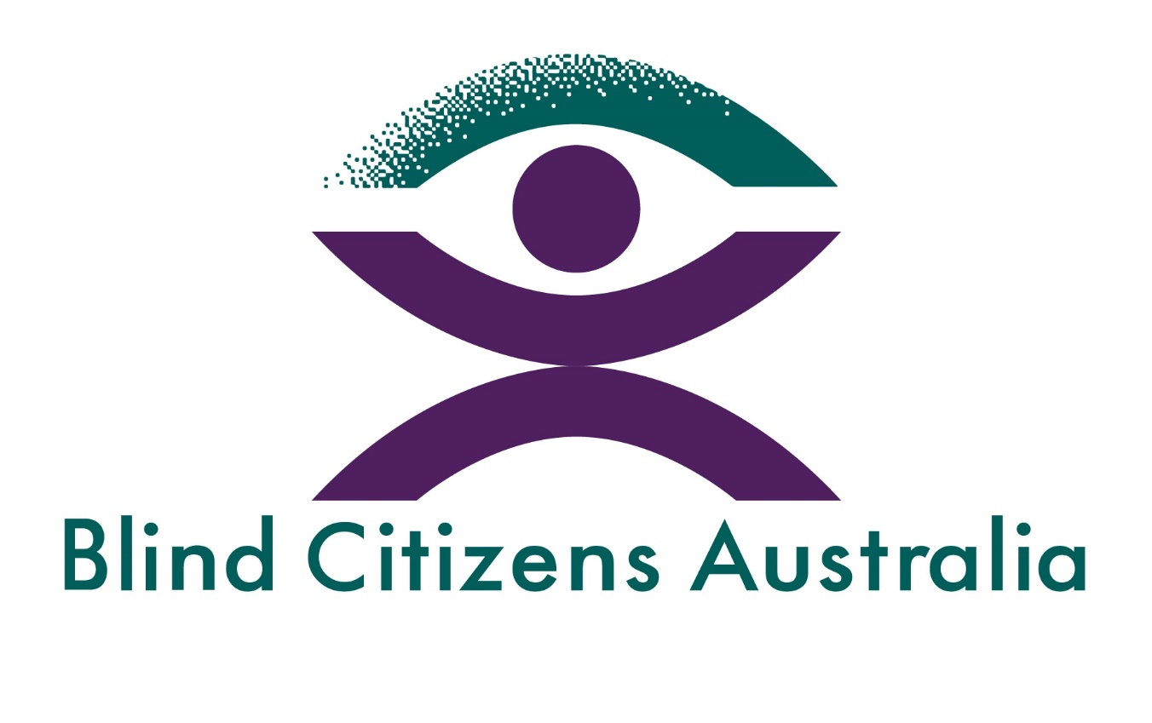
Guide Dogs NSW/ACT, 
and

Physical Disability Council of NSW. 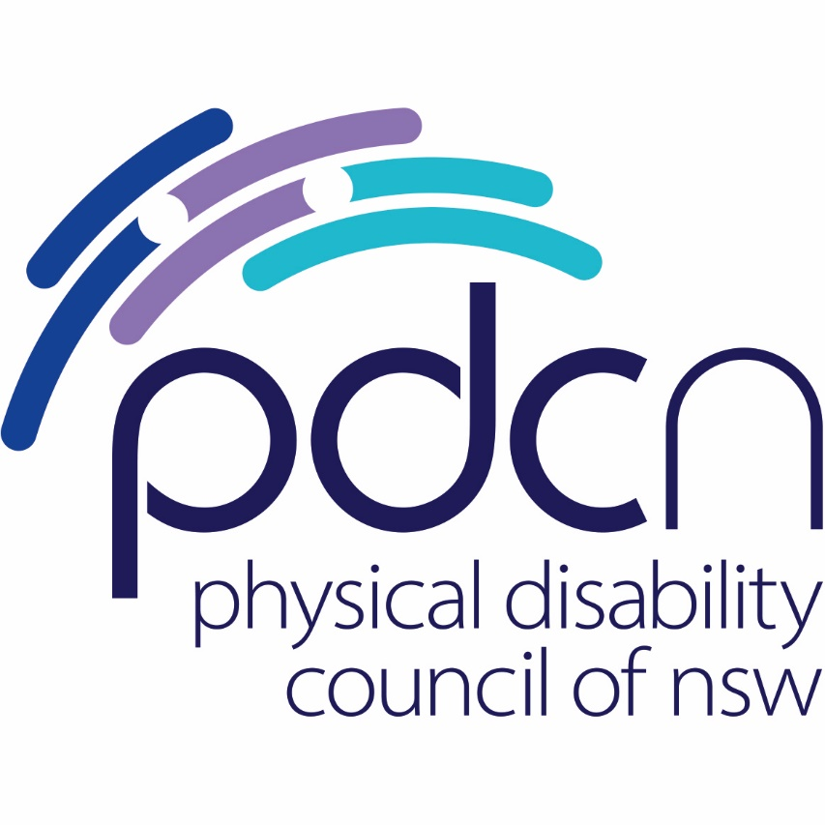

In our feedback We provide needed factual corrections and information about the NSW Vision Impaired Person’s Travel Pass (VIP Travel Pass), including that it has its origins in a concession that was introduced more than a century ago. We emphasise that this Travel Pass must be maintained, and that it must form the basis for regional travel concessions.

Vision Impaired Person’s Travel Pass
The NSW Vision Impaired Person’s Travel Pass began as a tram travel concession in 1911. A similar concession had been established in Victoria 20 years previously. The concession was extended to cover train travel in 1922 and was later expanded to include bus and ferry travel. It has been available to any person who meets the eligibility criteria in NSW.

The VIP Travel Pass is very clearly a travel concession that predates the Disability Standards for Accessible Public Transport by 90 years. Describing it as a “temporary equivalent access solution” is a complete mischaracterisation that is not consistent with the historical record. There is no mention of the temporary nature of this travel pass on the official information provided by Transport for NSW or Service NSW websites. Similar travel concessions for people who are blind or have low vision exist in all other Australian jurisdictions, and they also long predate the Disability Standards for Accessible Public Transport. Moreover, the existence of VIP Travel Passes in all states and territories shows clearly that there is an identified access requirement for the Travel Pass which has resulted in an established and ongoing program across the country.

The Standards themselves do not preclude the establishment or continuation of travel concessions (including the free travel allowed by the NSW VIP Travel Pass) and in practice the Standards have not previously been construed as requiring or implying a discontinuation or modification of such concessions. Similarly, the implementation of the Standards has not led to any attempt to reframe existing travel concessions as a “temporary equivalent access solution”.

It is also important to point out that the VIP Travel Pass concession also provides free travel for an additional person, the “attendant”. This is in recognition of the many barriers that people who are blind or have low vision face when travelling, especially to unfamiliar destinations. Again, this aspect of the Travel Pass has nothing to do with, and long predates, the Disability Standards for Accessible Public Transport.

While the VIP Travel Pass only allows free travel (for the holder and an additional person) on public transport in NSW, in practice many private bus operators have accepted it and provided the same concession. We are aware that transport operators in other jurisdictions also often accept the VIP Travel Pass, even though there are no formal reciprocal arrangements between the various jurisdictions.

The VIP Travel Pass has always been a greatly valued concession. It is an acknowledgement that people who are blind or have low vision cannot drive and so are not able to enjoy the benefits of private transport, and it allows them to use public transport to participate in the social, economic, cultural and recreational life of the community. It is our strong view that the Pass is a foundational support that is an essential component of the ecosystem of services and supports for people with disability in NSW, and that it therefore essential for it to be maintained.

The Opal Network and the VIP Travel Pass
The introduction of the Opal network was not intended to have an impact on the current operation of the VIP Travel Pass, and initially people who are blind or have low vision in NSW were not issued with an Opal card. However, an unintended consequence was that without an Opal card it was not possible to open the gates at railway stations, so as a result of representations that we made to the Transport Minister, VIP Travel Pass holders were issued with an Opal card. It was never the intention, and it was never suggested, that this Opal card would replace the Pass. This is expressed in official communications regarding the Pass from TfNSW and Service NSW, which state that the Opal is in addition to the Pass, not a replacement.

“You can use a free travel Opal card to open the ticket gates without staff. However, it is optional and for convenience. It is not a requirement for free travel.”

The Opal network was not designed to be accessible to people who are blind or have low vision, and it is still not accessible. For example, it is difficult or impossible for a person who is blind or has low vision to locate the Opal terminal, particularly if it is in an unpredictable and undetectable location such as on a pole somewhere at a railway station; the terminals themselves do not comply with accessibility standards, and there seems almost no likelihood that this will change in the foreseeable future. Developments in digital technology may improve the accessibility of Opal terminals for some people, but certainly not for all.

A key reason for the accessibility failures in the Opal network is that it was never envisaged that people who are blind or have low vision would need to use it to facilitate travel. The only interaction that people who are blind or have low vision would be required to have with the network would be to open the gates. In particular, there was never a suggestion made in discussions with the blindness and low vision sector that in the event that the significant accessibility barriers were ever resolved, the VIP Travel Pass would be taken away after more than a century of continuous operation.

Regional Concessions
Based on the background information provided by the Department as part of its request for feedback, it is not easy to penetrate the explanation of what the problem actually is. It does appear to us however that much of the problem results from a failure to acknowledge the current operation and historical continuity of the VIP Travel Pass. It is our firm view that any issues that affect people who are blind or have low vision travelling or living in regional areas in NSW will be most effectively and conveniently addressed by focusing on the current VIP Travel pass concession and modifying it if necessary, including by liaising with private transport providers to allow the VIP Travel Pass to be widely and predictably used.

Conclusion
We have prepared this feedback mindful of the value of constructive engagement and dialogue. However, we have also prepared it under considerable duress, given the unrealistic deadline imposed on us by the Department. Our organisations have limited time and limited resources, and failure to acknowledge this when establishing timeframes is not conducive to effective or meaningful consultation, and is certainly not in the spirit of courteous and respectful co-design.

As we have noted, our strong view is that issues related to regional travel concessions are best addressed from the standpoint of the existing VIP Travel Pass. Indeed, our strong view is that, as part of the creation of a framework of foundational supports, this concession must not only be maintained, but should also be extended to other people with a disability who are not able to drive and so are required to use public transport.

We are happy to have further discussions with the Department in a timely manner, and to provide the Minister with additional information if needed.

About Vision Australia
Vision Australia is the largest national provider of services to people who are blind, deafblind, or have low vision in Australia. We are formed through the merger of several of Australia’s most respected and experienced blindness and low vision agencies, celebrating our 150th year of operation in 2017.

Our vision is that people who are blind, deafblind, or have low vision will increasingly be able to choose to participate fully in every facet of community life. To help realise this goal, we provide high-quality services to the community of people who are blind, have low vision, are deafblind or have a print disability, and their families.

Vision Australia service delivery areas include: registered provider of specialist supports for the NDIS and My Aged Care Aids and Equipment, Assistive/Adaptive Technology training and support, Seeing Eye Dogs, National Library Services, Early childhood and education services, and Feelix Library for 0-7 year olds, employment services, production of alternate formats, Vision Australia Radio network, and national partnership with Radio for the Print Handicapped, Spectacles Program for the NSW Government, Advocacy and Engagement. We also work collaboratively with Government, businesses and the community to eliminate the barriers our clients face in making life choices and fully exercising rights as Australian citizens.

Vision Australia has unrivalled knowledge and experience through constant interaction with clients and their families, of whom we provide services to more than 30,000 people each year, and also through the direct involvement of people who are blind or have low vision at all levels of our organisation. Vision Australia is well placed to advise governments, business and the community on challenges faced by people who are blind or have low vision fully participating in community life.

We have a vibrant Client Reference Group, with people who are blind or have low vision representing the voice and needs of clients of our organisation to the board and management.

Vision Australia is also a significant employer of people who are blind or have low vision, with 15% of total staff having vision impairment.

The background to and early history of the travel concession is detailed in Campbell, James (1943) History of the Blind Association, Association of Blind Citizens and Club, Sydney.
https://transportnsw.info/tickets-opal/ticket-eligibility-concessions/people-with-disabilities/vision-impaired-person

